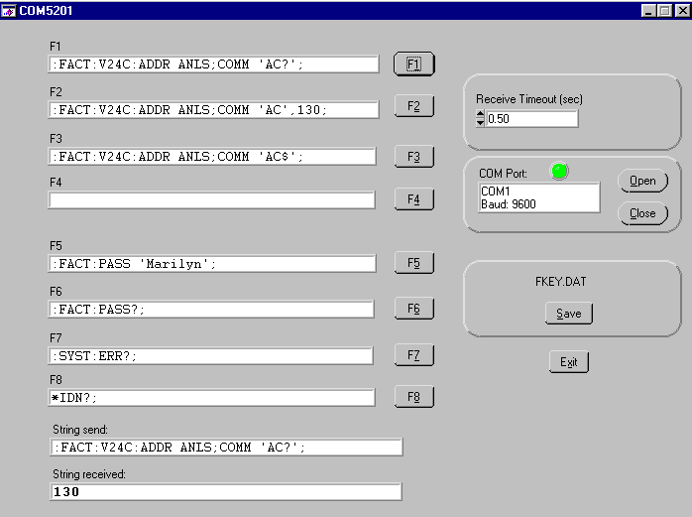
Adjustment of DC-offset on PT8601 analog generator.

:FACT:V24C:ADDR ANLS;COMM 'AC?';

Note:
- semicolon after unit name ANLS
- space between COMM and ’AC?’
- use correct single/double quote (alt+39 or alt+34)

